OCEANA COUNTY

JUNIOR MARKET

GOAT RECORD BOOK – 2023

(for ages 5-7 years old)



**IF YOU ARE A LITTLE BUDDY PLEASE CHECK HERE:** _____

**My big buddy is: _________________________________________**

As a member of the Junior Market Animal Project, you are required to submit your records as part of an educational project notebook in order to show your animal at the Oceana County Fair. **This notebook must be shown to the Goat Superintendent or designated Small Market Weighmaster at the time of weigh-in and then entered by you in the Educational Notebook Division at the Oceana County Fair on Entry Day.**

**AGE: __________**

The age you enter depends on how old you were on January 1, 2023

**NUMBER OF YEARS IN PROJECT: ____________**

Use this sheet as the first page of your project record book. Fill it out completely.

**Please print or type neatly.**

# NAME ________________________________________________________________

**4-H CLUB _____________________________________________________________**

##### LEADER ______________________________________________________________

**DATE RECORDS STARTED _________________ DATE ENDED _____________**

**JUDGE’S SCORE/COMMENT SHEET**

**(PLEASE DO NOT REMOVE, PLACE THIS SHEET IN SHEET PROTECTOR OR GLUE TO COVER). This sheet must be keep free to the judge to write their comments.**

This sheet should help each junior market member understand their ribbon placing.

A. **Specific educational value or worth**

___ All questions were answered completely

___ All calculations were correct

___ Calculations were incorrect

___ Questions were not completely answered

___ Questions were not answered (missed questions)

B. **Notebook contains all project records**

___ Notebook contained all project records and were fully completed

___ Notebook contained additional project related information (research

materials etc.)

___ Project records were incomplete

___There was no additional project related information

C. **Accuracy, neatness and general appearance**

___Notebook was neat in appearance (typed/hand printed)

___ Notebook pages were clean and stain free

___Notebook pages were in order and complete

___Notebook pages were out of order and missing pages

___Notebook was difficult to read and messy

___Notebook had wrinkled and stained pages

Other Comments: ___________________________________________________________

__________________________________________________________________

2023-Jr. Market Goat Page 2

## OBJECTIVES

1. **To let members experience love of animals.**
2. **To members to experience the obligations and responsibility required in a livestock enterprise.**
3. **To let members experience and cope with the “values” and “attitudes” of responsibility in a relatively unsupervised environment. Supervision will be provided on a periodic basis.**
4. **To allow the member to provide meat for the family table and/or to experience the marketing process and system through sale of his project.**
5. **To let the member experience competition by fitting and showing their animal at local or area organizational sponsored shows and the Fair.**

This record book is part of your Junior Market Goat project. By keeping records up-to-date you will be able to see how much progress you make as you set goals and work to accomplish them. Write or type neatly and clearly. Please keep the pages in order. Feel free to add extra pages at the end of your notebook.

SCORING CRITERIA

The following breakdown will be used during the judging process of all market livestock notebooks.

A. Specific educational value or worth **30%**

B. Creative way of showing what has been learned **10%**

C. Notebook contains all project records **50%**

D. Accuracy, neatness and general appearance **10%**

The Oceana County Agricultural Society encourages parent assistance with your project and project notebook. If you should have any questions, please contact the MSU Extension Office.

**If a parent or an adult helped you in filling out your notebook** please have them sign below that the answers are YOUR answers and that they assisted you in the writing of the answers and the understanding of the questions only.

______________________________________________________________

(Signature of person helping with notebook)

______________________________________________________________

(Printed name of member)

2023-Jr. Market Goat Page 3

**ABOUT YOUR GOAT:**

**My Goat’s Name**: ________________________________________________

**My Goat’s Breed**: _________________________________________________

**My Goat’s Color(s) are**: ___________________________________________

**My goat is a** (circle one): ***Wether*** (boy) ***Doe*** (girl)

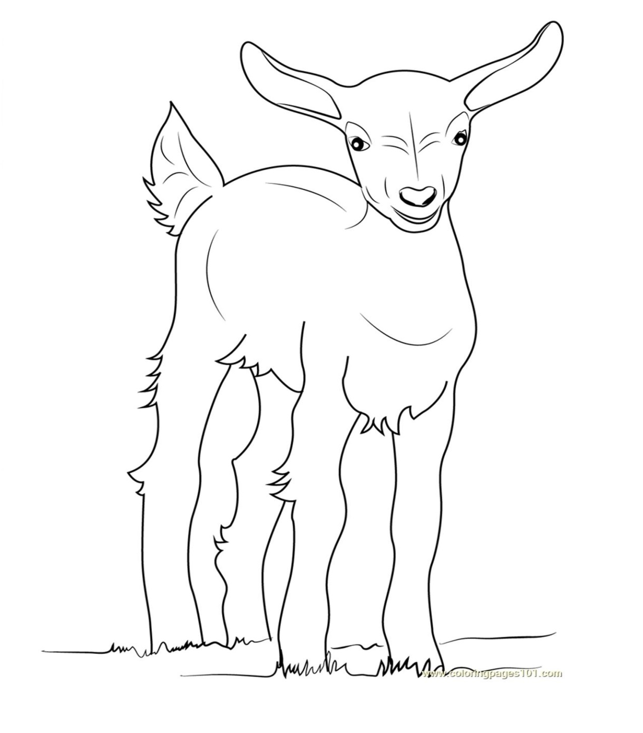

**COLOR THE GOAT**

**TO LOOK LIKE**

**YOURS**

2023-Jr. Market Goat Page 4

### WEIGHT CHART

(have a parent, grandparent, leader, older youth, etc. ***help*** you with the next sections)

BEGINNING WEIGHT_______­­___ AGE______­­­_ DATE___________

|  |  |  |
| --- | --- | --- |
| **WEEK** | **AGE** | **WEIGHT** |
|  |  |  |
|  |  |  |
|  |  |  |
|  |  |  |
|  |  |  |
|  |  |  |
|  |  |  |
|  |  |  |

FINAL WEIGHT (FW)_____________AGE_____________DATE_____________

**\*final weight may have to be estimated depending upon Covid 19 restrictions in summers of 2021.**

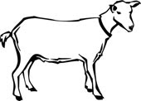

###### 2023-JR Market Goats Page 5

###### EXPENSES

##### (A) Cost of kid $______________

|  |  |  |  |
| --- | --- | --- | --- |
| **DATE** | LBS. OF FEED | FEED- VARIETY/TYPE | COST |
|  |  |  | **$** |
|  |  |  |  |
|  |  |  |  |
|  |  |  |  |
|  |  |  |  |
|  |  | **(B) TOTAL SPENT ON FEED** | **$** |

|  |  |  |
| --- | --- | --- |
| **DATE** | OTHER EXPENSES, VET, SUPPLIES, HOUSING, MARKETING, ETC. | COST |
|  |  | **$** |
|  |  |  |
|  |  |  |
|  | **(C) TOTAL SPENT ON OTHER EXPENSES** | **$** |

##### GRAND TOTAL OF ALL EXPENSES (TE): $ ____________ (TE)

**(total of A,B, and C)**

**__________________ ÷ __________________ = ___________________________________**

Total Expenses **(TE)** Final Weight **(FW**) Break Even Price **(BE)** (or total cost per pound to raise your animal)***\*\****

***+final weight may be an estimate depending on Covid 19 restrictions***

***\*\*have your parent, leader or an older teen in your club help you figure out your breakeven price (BE). The breakeven price is the price that you need to get at the Junior Market animal auction in order to not lose money on your market project\*\****

2023-JR Market Goats Page 6

**ANIMAL CARE AND MANAGEMENT**

Your project requires regular care and management. List the things necessary to take care of your project animal(s).

Include the following:

* Feeding and watering practices
* Grooming (clipping, hoof trimming, etc.)
* Health practices and medicines
* General Management (cleaning living area, etc.)

|  |
| --- |
| **Daily- Things done once or twice a day** |
|  |
| **Weekly- Things done once or twice a week** |
|  |
| **Monthly- Things done once a month** |
|  |
| **Yearly- Things done one time or occasionally throughout the year** |
|  |

2023-Jr Market Goats PAGE 7

**MARKETING**

One of the most important parts of any market animal project is marketing. This may include writing letters and talking to prospective buyers. Color in the face, a smiling face is a good action, a frowning face is a bad action. (see the example)

**Good Marketing Practice Poor Marketing Practice**

























Send a picture to your potential buyers

Send a reminder to attend the auction

Let an adult talk to the buyer instead of you talking to them

Know what kind of feed you used if asked

Make sure to visit your previous buyers

Only thank those who agree to be listed as a potential buyer

**WHAT DOES YOUR GOAT NEED?**

(have an adult help you read the following & then **circle those items that your goats** need below)

All living creatures need certain things to survive, like *food*, *water* and *shelter*. *Farmers* take care of their animals to make sure they are healthy and comfortable. If any animals are sick the farmer will treat them with the help of the *veterinarian.* Goats need roughage such as *grass* to keep their digestive system working correctly. Some plants such as *Lily of the Valley* & *Oleander* are **not** good for your goat to eat.

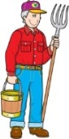 FARMER VETERINARIAN JAPANESE YEW WATER

COOKIES BARN GRASSES MILKWEED

2023-Jr Market Goats Page 8

**PARTS OF A GOAT**

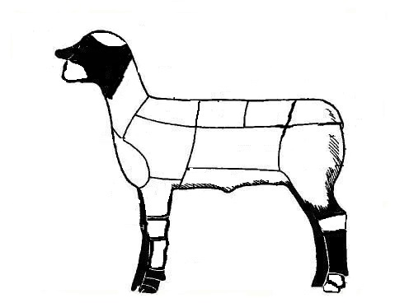

**COLOR THE PARTS OF THE GOAT**

Back or Rack- Red Belly- Yellow Breast/Brisket-Pink Cannon- Purple Dock- Pink Forearm- Purple Hock- Red Hoof- Orange Knee- Red Leg- Blue Loin- Green Middle- Orange Muzzle- Blue Neck- Yellow Pastern- Brown Poll- Red Shoulder- Green Top of Shoulder- Purple

2023-Jr Market Goats Page 9

**PROJECT KNOWLEDGE**

###### MATCH THE ANSWERS TO THE CORRECT QUESTIONS

(draw a line from the question to the correct answer)

1. A goat of either sex under one year old A. Water

2. A goat’s hair or wool is called B. Doe

### 3. A female goat C. Yearling

4. Most important part of a goats diet D. Fleece

5. The first milk, it is full of antibodies for the kids E. Colostrum

6. A goat between the age of one and two years old F. Kid

**Match Them Up**

(write the letter that answers the question on the line before it)

_____ 1. Meat goats prefer what type of grazing? **A**. Small shed or barn

_____ 2. Who you might call when a goat gets sick **B**. Sportsmanship

_____ 3. What kind of housing does a goat need? **C**. Electric fence or woven wire 4 feet high

_____ 4. How is goat milk used? **D**. Clean, dry straw

_____5. The most important food your goat needs **E**. Good-quality hay and grasses

_____ 6. What do goats sleep on?  **F.** Browse

_____ 7. How would you keep a goat fenced in?  **G**. Veterinarian

_____ 8. A goat eats grain and . . . **H**. Drink it, sell it or make cheese & butter

_____9. Honest & Courteous when competing  **I.** Water

2023-JR Market Goats Page 10

**PROJECT INFORMATION**

**What Does Not Belong?**

In each statement one word does not belong, ***X (cross)*** out that word.

1. Goats have: **teeth, eyes, withers, feathers**

2. For a goat’s fencing use: **barbed wire, woven wire, electrical fence**

3. The people who help me take care of and learn about my goats are:

**my parents, the veterinarian, my principal, my club leader**

4. Goat breeds: **Boer, Kiko, Nubian, Cornish Rock**

**Finish the Sentences**

1. My goat always needs clean, fresh _______________________________ to drink.

2. When I grow up I want to be a ___________________________________________.

3. The best, or most fun, part of my project was: _____________________________ ______________________________________________________________________________ ______________________________________________________________________________

______________________________________________________________________________

4. The hardest part of my project was: _____________________________________ ______________________________________________________________________________ ______________________________________________________________________________

2023- JR Market Goat Page 11

**Identify Good & Bad Character Actions**

Color in the face, a smiling face = a good action, a frowning face = a bad action.

(see the example)

**RAISING and SHOWING an RAISING and SHOWING an**

**ANIMAL *with* CHARACTER ANIMAL *without* CHARACTER**





































Feed Animals on Time

Complete your record book honestly

Thank the judge no matter how you placed

Leave animals outside without shelter

Help others if they need it

Leave your pen for your parents to clean

Leave manure on the barn floor

Always try your best

Take others equipment without asking them

How did you show good character this year? Did you help someone, or maybe you treated your animals extra special?

___________________________________________________________________________________

___________________________________________________________________________________

___________________________________________________________________________________

___________________________________________________________________________________

2023-JR Market Goat Page 12

**4-H KNOWLEDGE**

**The 4-H Pledge**- *Draw a line to the picture that fills in the blank* (see the example)

***I pledge…***

HANDS

HEALTH

HEAD

HEART

WORLD

COUNTRY

CLUB

COMMUNITY

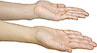









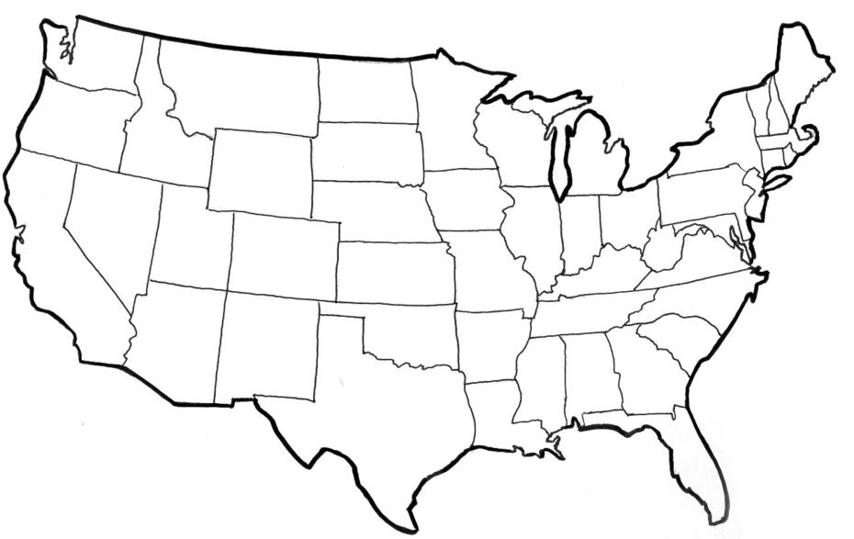





My ____________ to clearer thinking,

My ____________ to greater loyalty,

My ____________ to larger service, and

My _____________ to better living,

for my ____________________,

my _______________________,

my _______________________,

and my ____________________.

Number of club meetings held: **________** Number I attended: **_________**

2023-JR Market Goat Page 13

**MY STORY**

(Interesting things that happened to me and my animal this year, challenges, highlights of my year or ***ANYTHING*** I would like to share about my overall

experience. You can even draw a picture of you and your animals if you prefer).

***POTENTIAL BUYERS NAMES***

As part of your 4-H Small Market Livestock Project, you must personally contact at least three potential buyers before the Oceana County Fair. You are encouraged to seek two new buyers that have not been asked or submitted before. **You also must have at least three different buyers than those of your siblings in the market livestock project.** Please confirm with your buyers their accurate mailing address (example: post office box vs. a street address). The information on page 14 must be completed and taken to the Oceana County MSU Extension Office on or before the due date where it will be **copied** and used to send out letters to your potential buyers. This page will remain in your notebooks. This is a Market Livestock Committee rule. Failure to comply will result in not being able to sell your animal in the 4-H Market Livestock Sale.

2023-JUNIOR MARKET GOATS Date: _______________

PAGE 14 Staff: _______________

**JUNIOR MARKET/SMALL MARKET POTENTIAL BUYER’S LIST**

**GOAT PROJECT (AGES 5-7)**

Name______________________________ Club_________________________

***Please print business names and complete addresses clearly.***

* 1. Contact Name ________________________________________________­­____

Business Name ____________________________________________________

**Mailing** Address _________________________City__­­­­­­­­__­­­­­­­_____________Zip_____

Phone _______________________ After Hours Phone______________________

Mailing Preference (Please Check One): Email ____ Postal Delivery ____

Email ____________________________________________________________

Signature__________________________________________________________

2. Contact Name ________________________________________________­­____

Business Name ____________________________________________________

**Mailing** Address _________________________City__­­­­­­­­__­­­­­­­_____________Zip_____

Phone _______________________ After Hours Phone______________________

Mailing Preference (Please Check One): Email ____ Postal Delivery ____

Email ____________________________________________________________

Signature__________________________________________________________

3. Contact Name ________________________________________________­­____

Business Name ____________________________________________________

**Mailing** Address _________________________City__­­­­­­­­__­­­­­­­_____________Zip_____

Phone _______________________ After Hours Phone______________________

Mailing Preference (Please Check One): Email ____ Postal Delivery ____

Email ____________________________________________________________

Signature__________________________________________________________

(Must be stamped by the MSU Extension Office)

2023- JR Market Goats Page 15

**PICTURES OF YOUR PROJECT**

(Please use this page for your project pictures. Add additional pages if you would like. The judges appreciate you labeling the pictures so they

know what the picture shows.)

***NON-CLUB* POINTS- JUNIOR/SMALL MARKET PROJECT**

***(This must be filled out by participant before presenting for signatures at the MSUE office)***

|  |  |  |  |  |
| --- | --- | --- | --- | --- |
| **MEETING NAME** | **LOCATION** | **DATE** | **POINTS** | **SIGNATURE OF LEADER, SUPERINTENDENT OR MSU STAFF** |
|  |  |  |  |  |
|  |  |  |  |  |
|  |  |  |  |  |
|  |  |  |  |  |
|  |  |  |  |  |
|  |  |  |  |  |
|  |  |  |  |  |
|  |  |  |  |  |
|  |  |  |  |  |
|  |  |  |  |  |

Please note: This form must be included with your record notebook and turned into the weigh master on entry day of the Fair. **BEFORE SEEKING SIGNATURES AT MSU EXTENSION – MEETING NAME AND DATE MUST BE COMPLETED** You need to accumulate **nine (9) points** to be allowed to sell your animal. **Six (6)** of these **nine (9) points** must come from club meetings. The **three (3)** non-club points must be earned from attending various 4-H events and activities. See your leader, the MSUE office, or online at <https://www.canr.msu.edu/oceana/oceana_county_4_h/oceana_4_h_market_livestock> for a listing of approved nonclub points.

**JUNIOR/SMALL MARKET PROJECT CLUB POINTS**

***(This must be filled out by participant before presenting for signatures at the MSUE office)***

|  |  |  |  |  |
| --- | --- | --- | --- | --- |
| **MEETING NAME** | **LOCATION** | **DATE** | **POINTS** | **SIGNATURE OF LEADER, SUPERINTENDENT OR MSU STAFF** |
|  |  |  |  |  |
|  |  |  |  |  |
|  |  |  |  |  |
|  |  |  |  |  |
|  |  |  |  |  |
|  |  |  |  |  |
|  |  |  |  |  |
|  |  |  |  |  |
|  |  |  |  |  |
|  |  |  |  |  |
|  |  |  |  |  |

Please note: This form must be included with your record notebook and turned into the weigh master on entry day of the Fair. You need to accumulate **nine (9) points** to be allowed to sell your animal. **Six (6)** of these **nine (9) points** must come from club meetings. The **three (3)** non-club points must be earned from attending various 4-H events and activities